

Flower Management System

Software Requirement Specification

HCM, NOV 2023 –

Table of Contents

I. Overview

1. Introduction

2. Database

3. System Functions

II. Functional Requirements

**I. Overview**

**1. Introduction**

My project is a website that sells flowers. There are 2 roles: Admin and User. In the home page, you can see the flowers list and add it to your cart, register a new account, login ,view your cart and search the flower by name or by category. When Login as a User, you can view the order,completed order, canceled order, processing order or choose to update your profile. When logging in with the Admin role, you can manage accounts, can manage order, manage plant, manage categories.

**2. Database**

- Database Name: PlantShop

+ Account

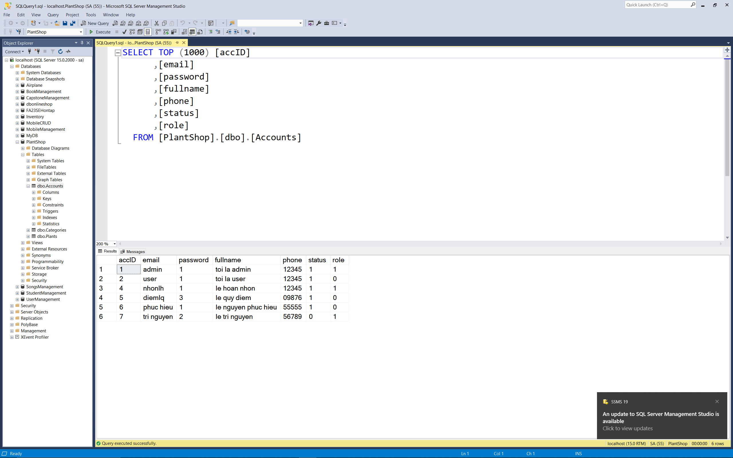

+ Categories

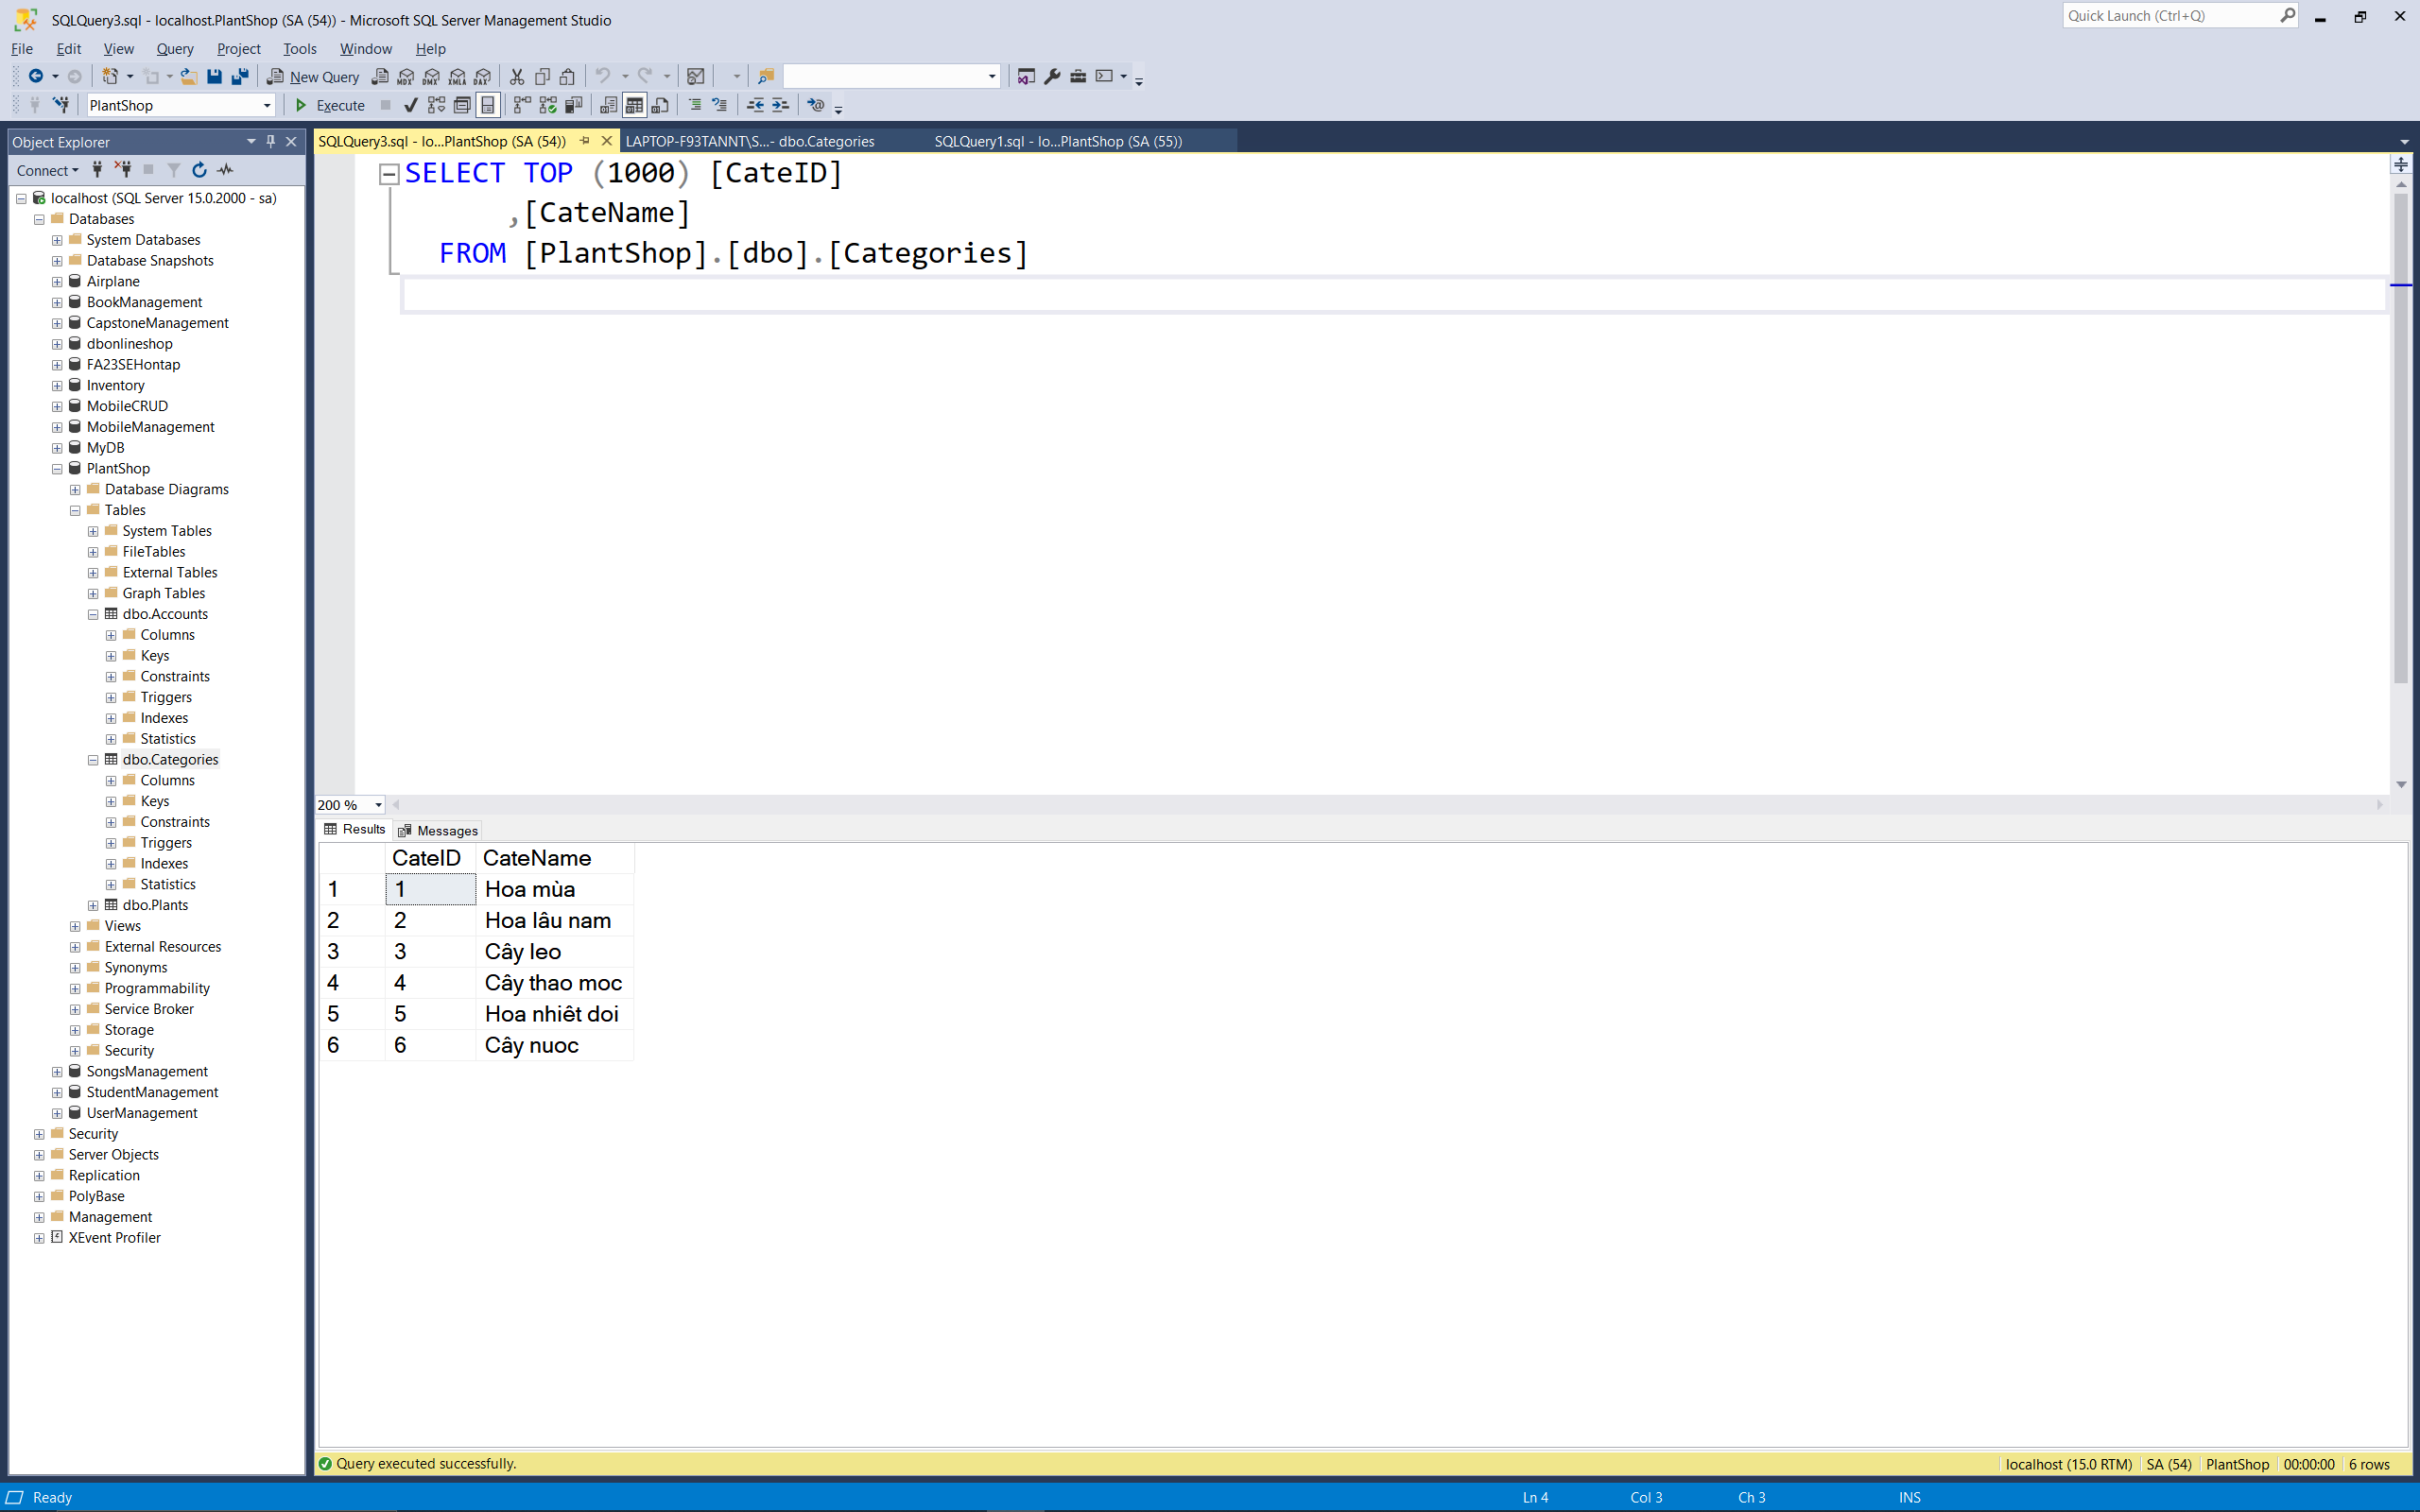

+ Plants

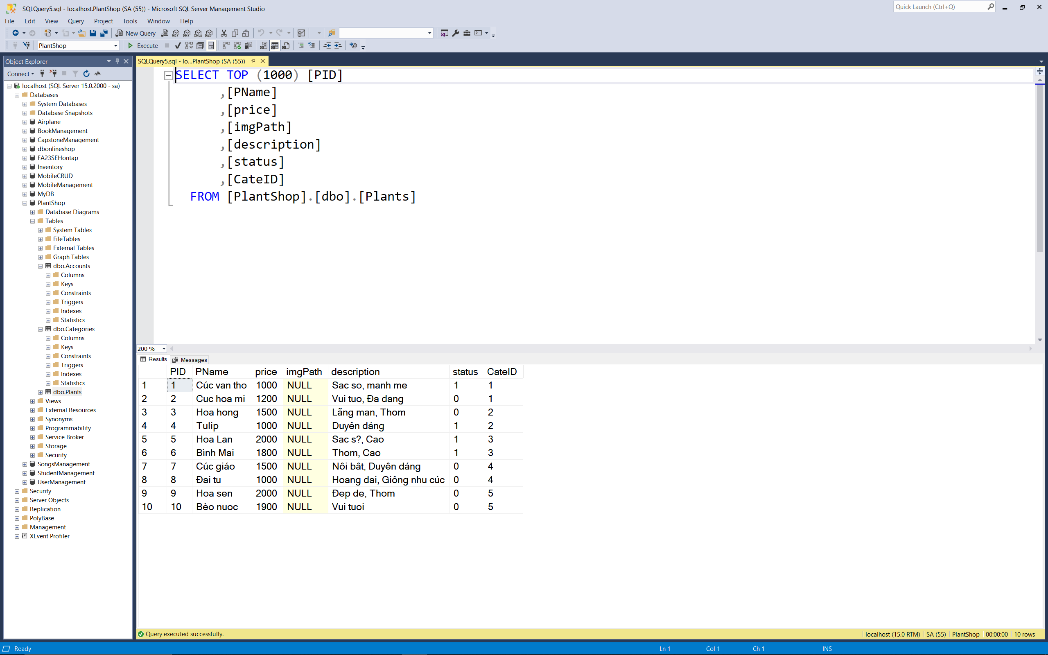

1. **System funtions**

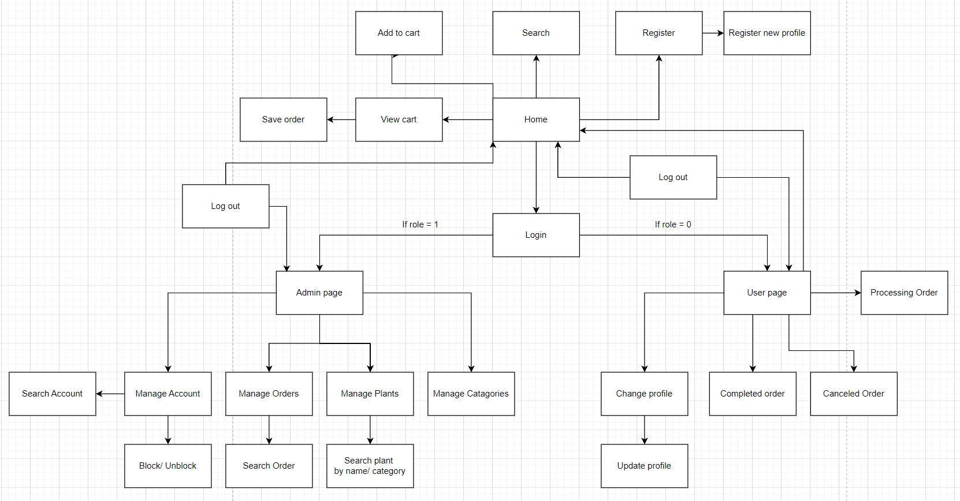

User Web Application

|  |  |  |  |
| --- | --- | --- | --- |
| **#** | **Feature** | **Screen** | **Description** |
| 1 | Login | Login lage | Contains text box to input username and password, login button. |
| 2 | Register | Register page | Contains text box to input user information, register button. |
| 3 | Add to cart | Home page | Contain item that user can add to cart and save cart |
| 4 | View cart | View cart page | View items added to cart that user can delete, update and save cart |
| 5 | Change profile | Change profile page | Contains text box to input user new information, update button. |
| 6 | Completed orders | Completed orders page | View completed order |
| 7 | Canceled order | Canceled order page | View canceled order |
| 8 | Processing order | Processing order page | View processing order |
| 9 | Logout | Home page | Log out of user account and go back to home page |

User Web Application

|  |  |  |  |
| --- | --- | --- | --- |
| **#** | **Feature** | **Screen** | **Description** |
| 1 | Login | Login lage | Contains text box to input username and password, login button. |
| 2 | Manage account | Manage account page | View all account and can block or unblock user account |
| 3 | Manage order | Manage order page | View all orders and accept or refuse order |
| 4 | Manage Plants | View plants page | View all plants and update them by changing plant’s stock and information |
| 5 | Change profile | Change profile page | View all categories and change their name |
| 6 | Logout | Home page | Log out of admin account and go back to home page |

**II. Functional Requirements**

**1. Login**

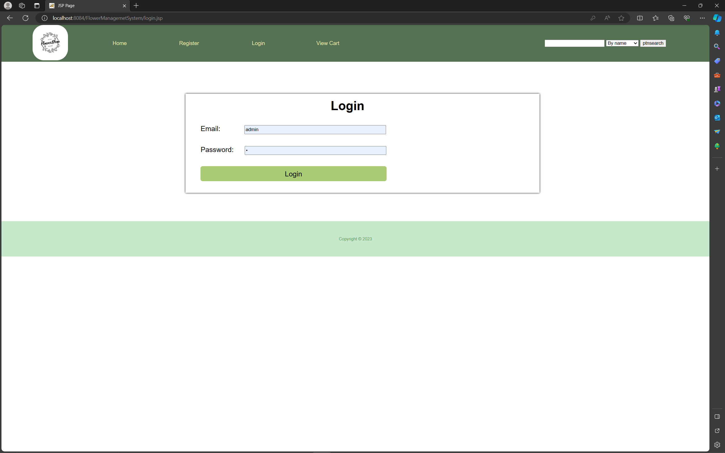

1. **Register**

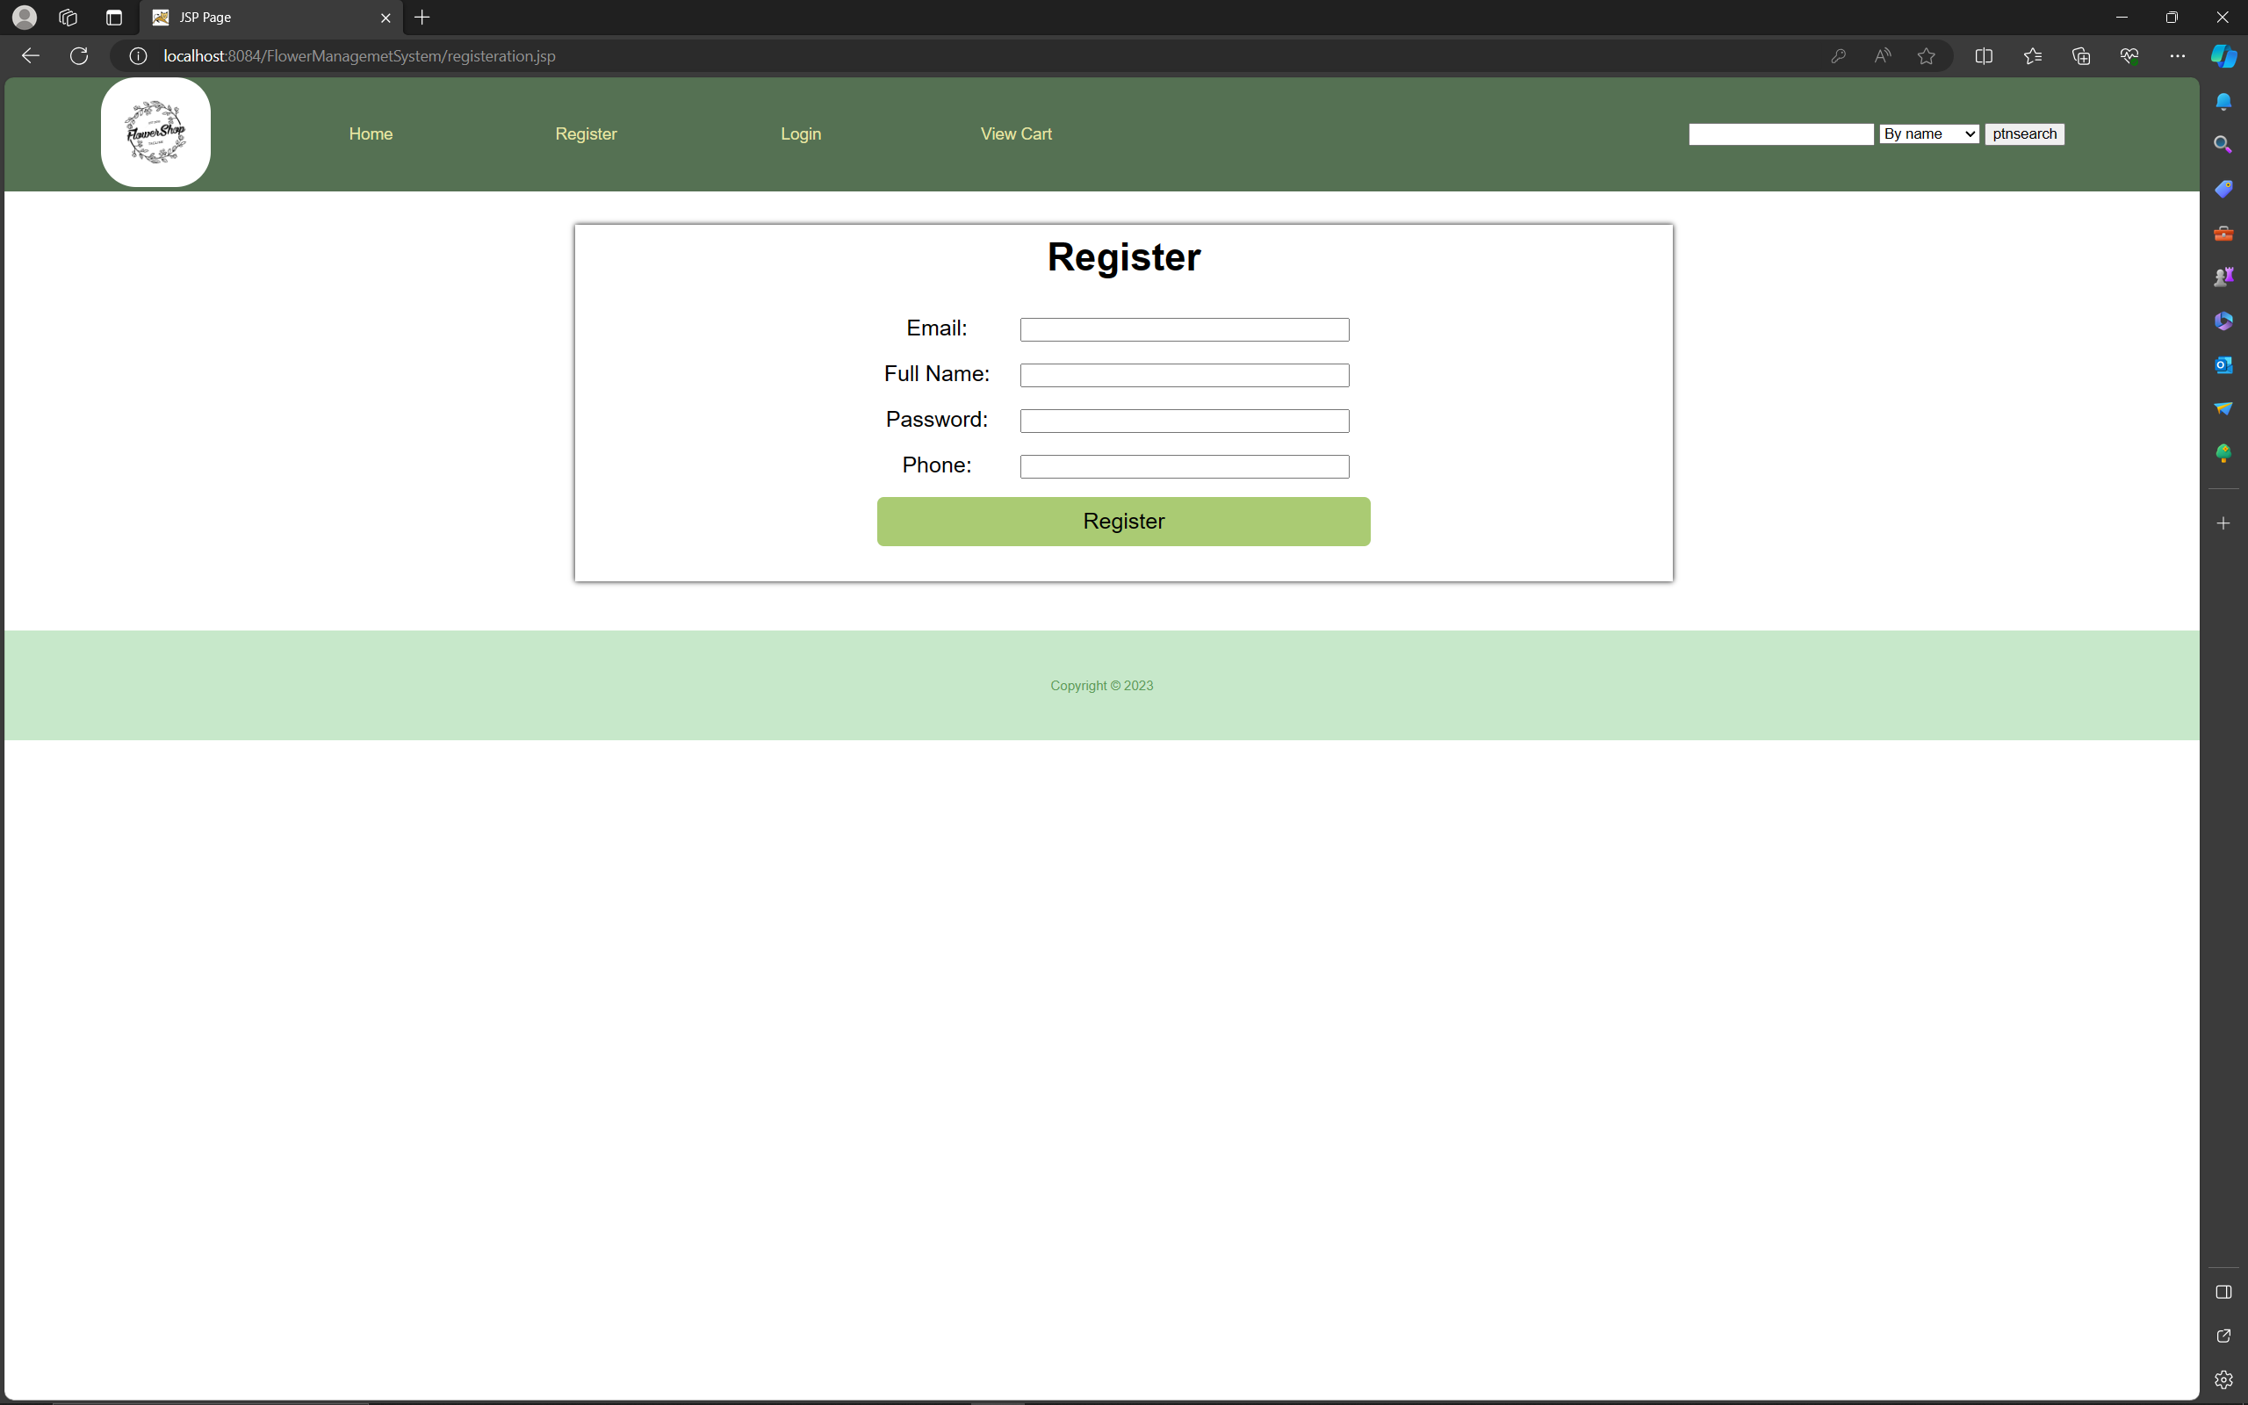

1. **Home**

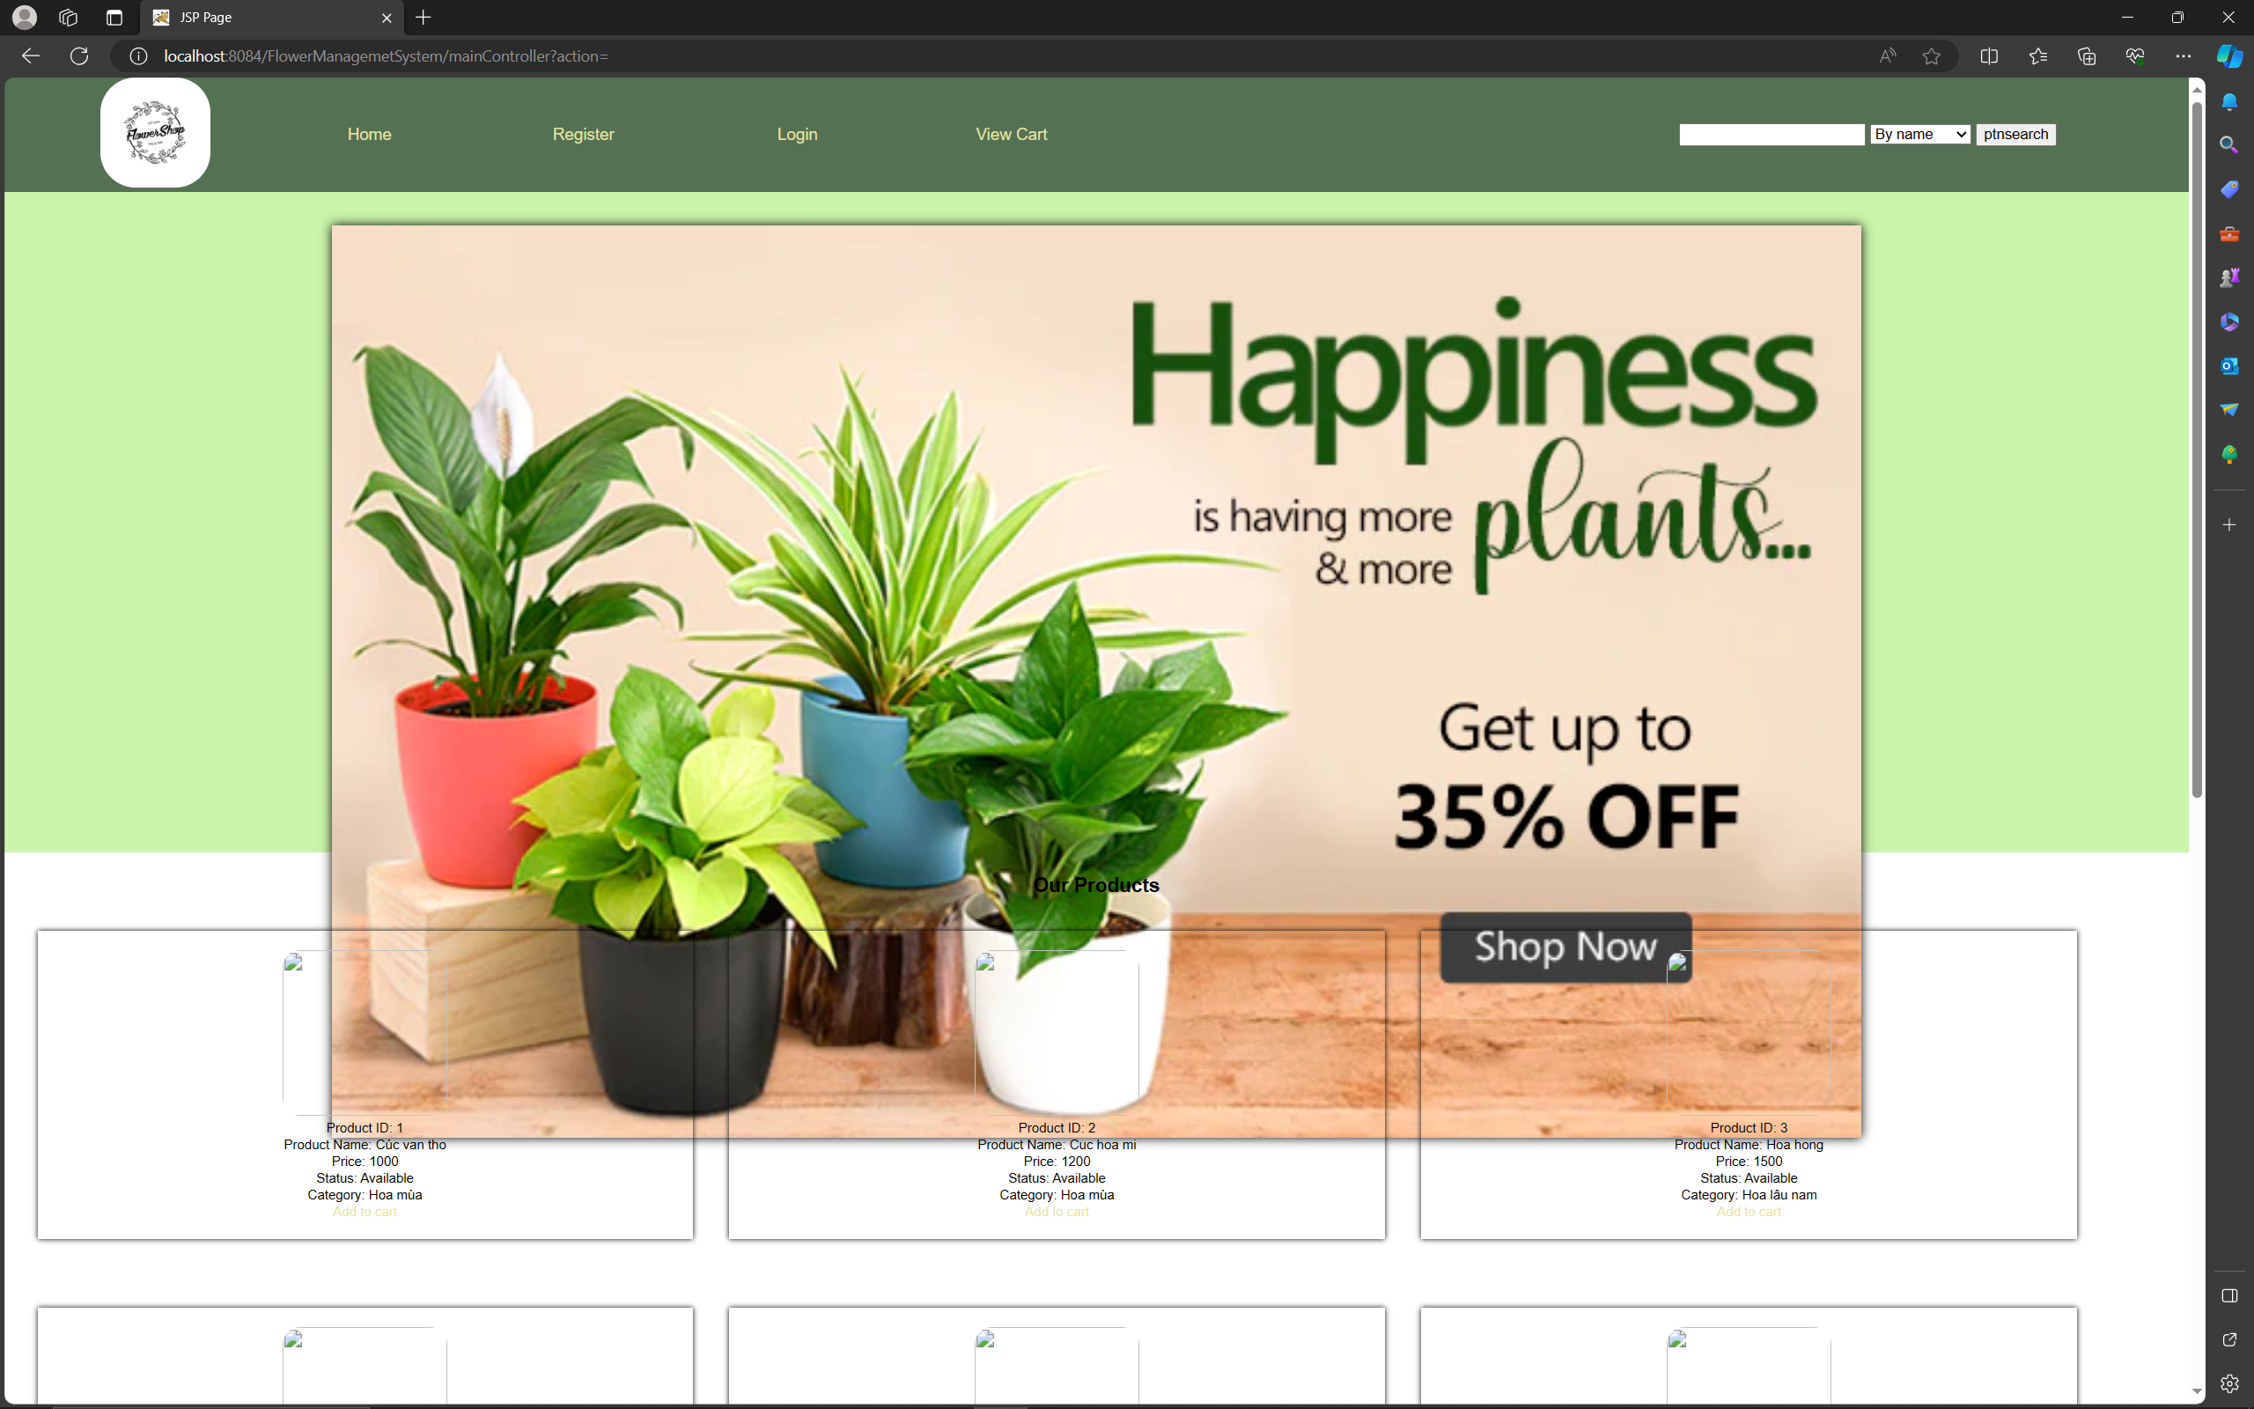

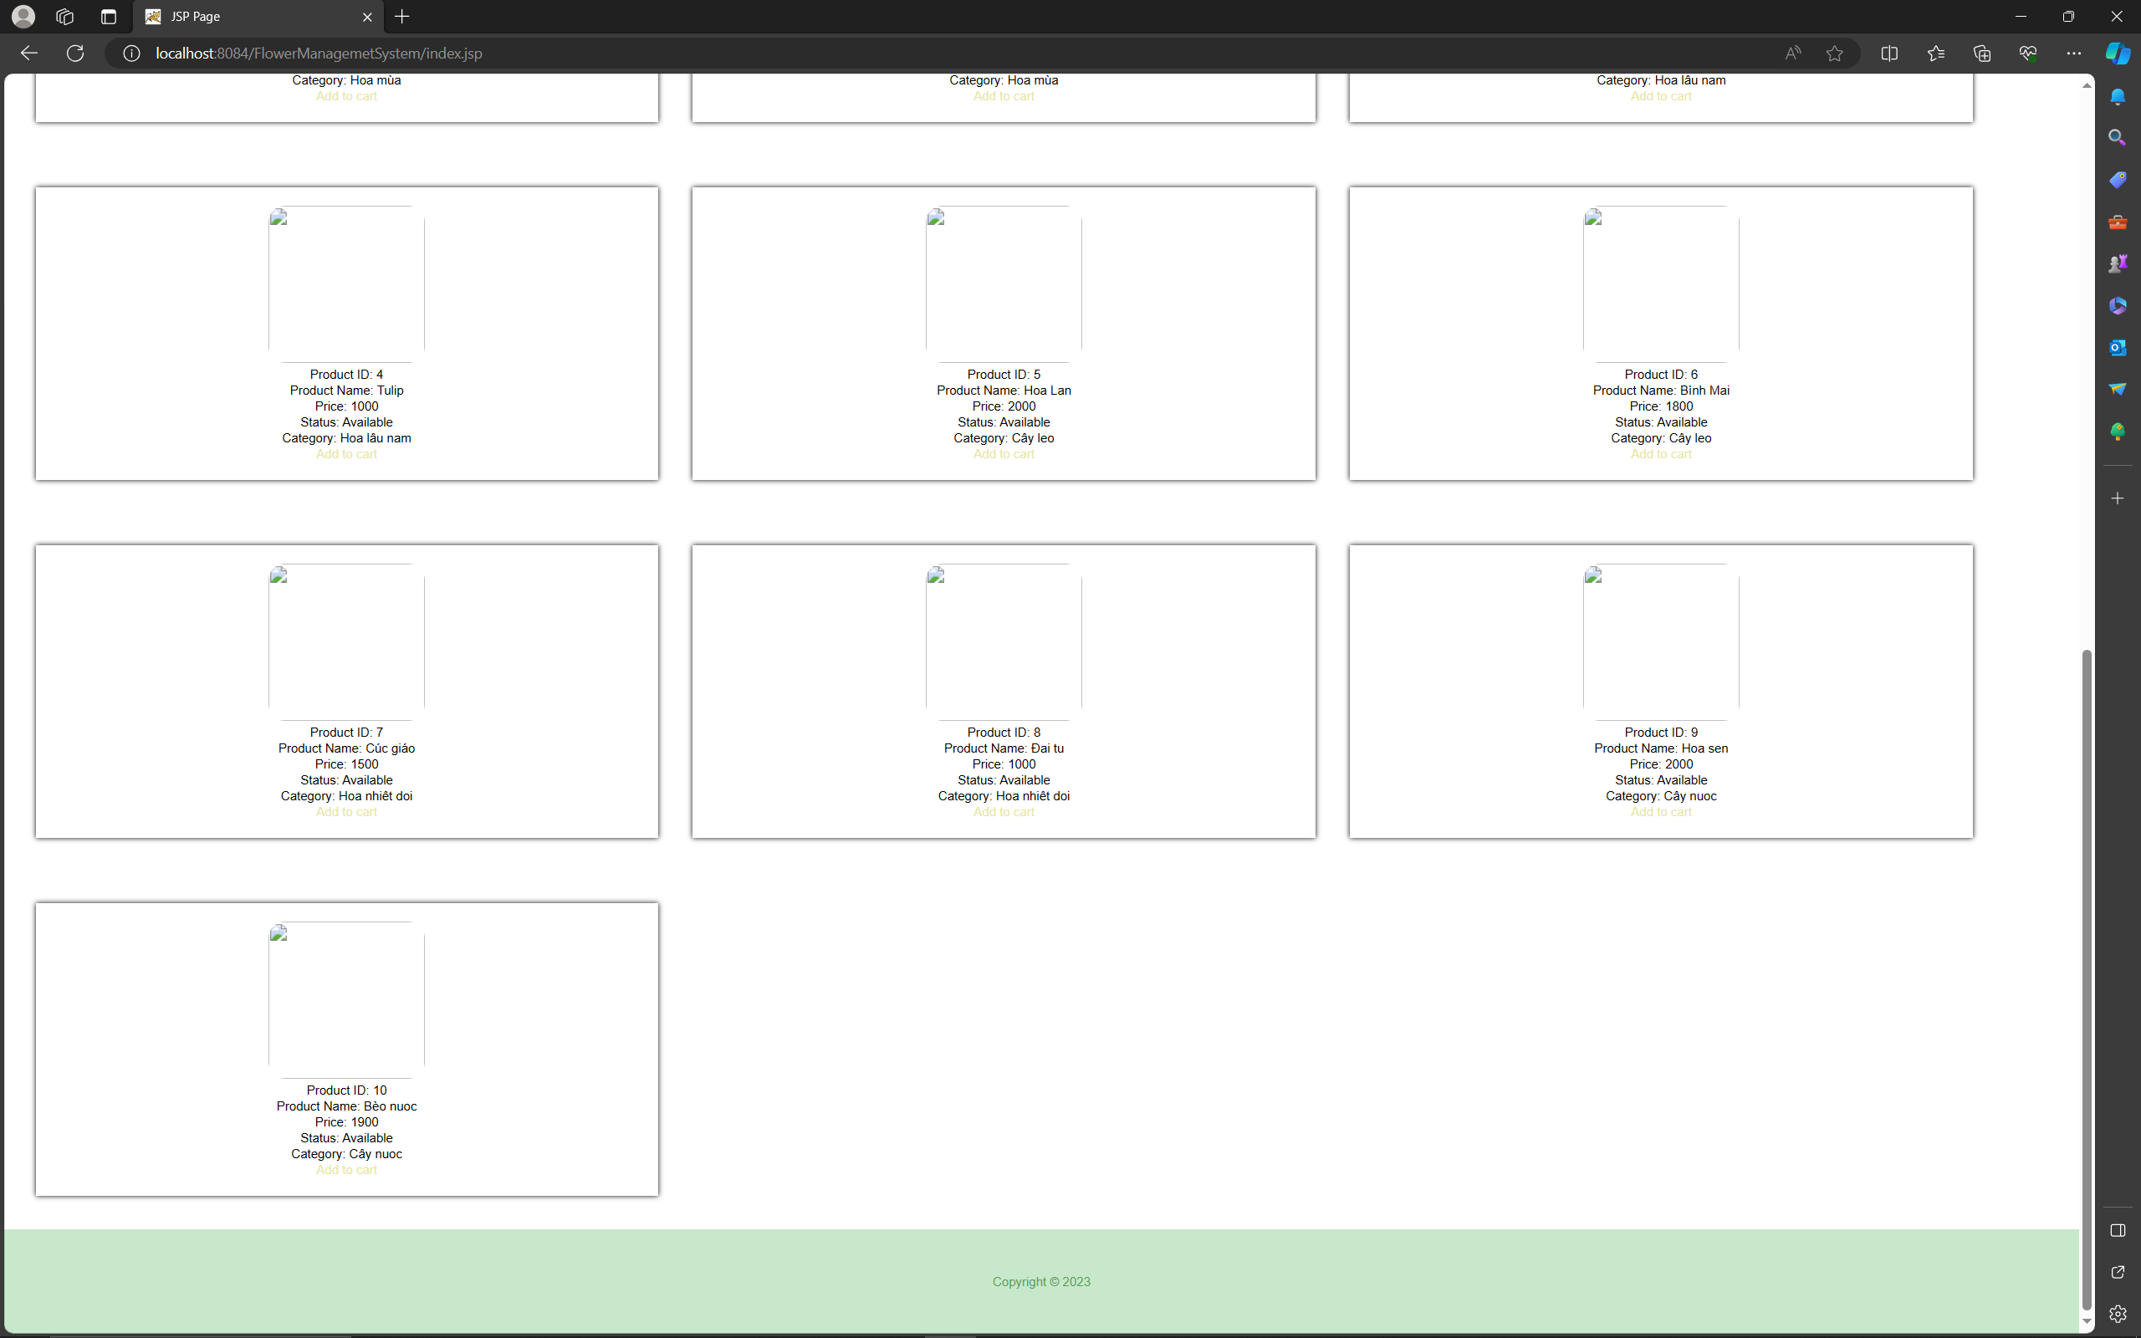

1. **View cart**

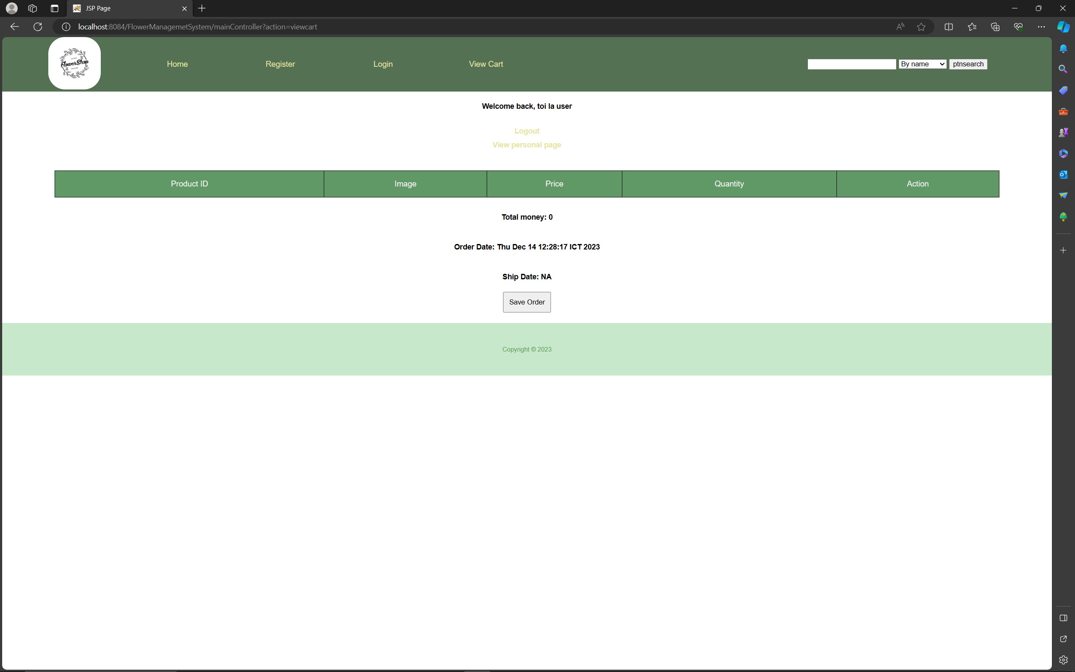

1. **Change profile**

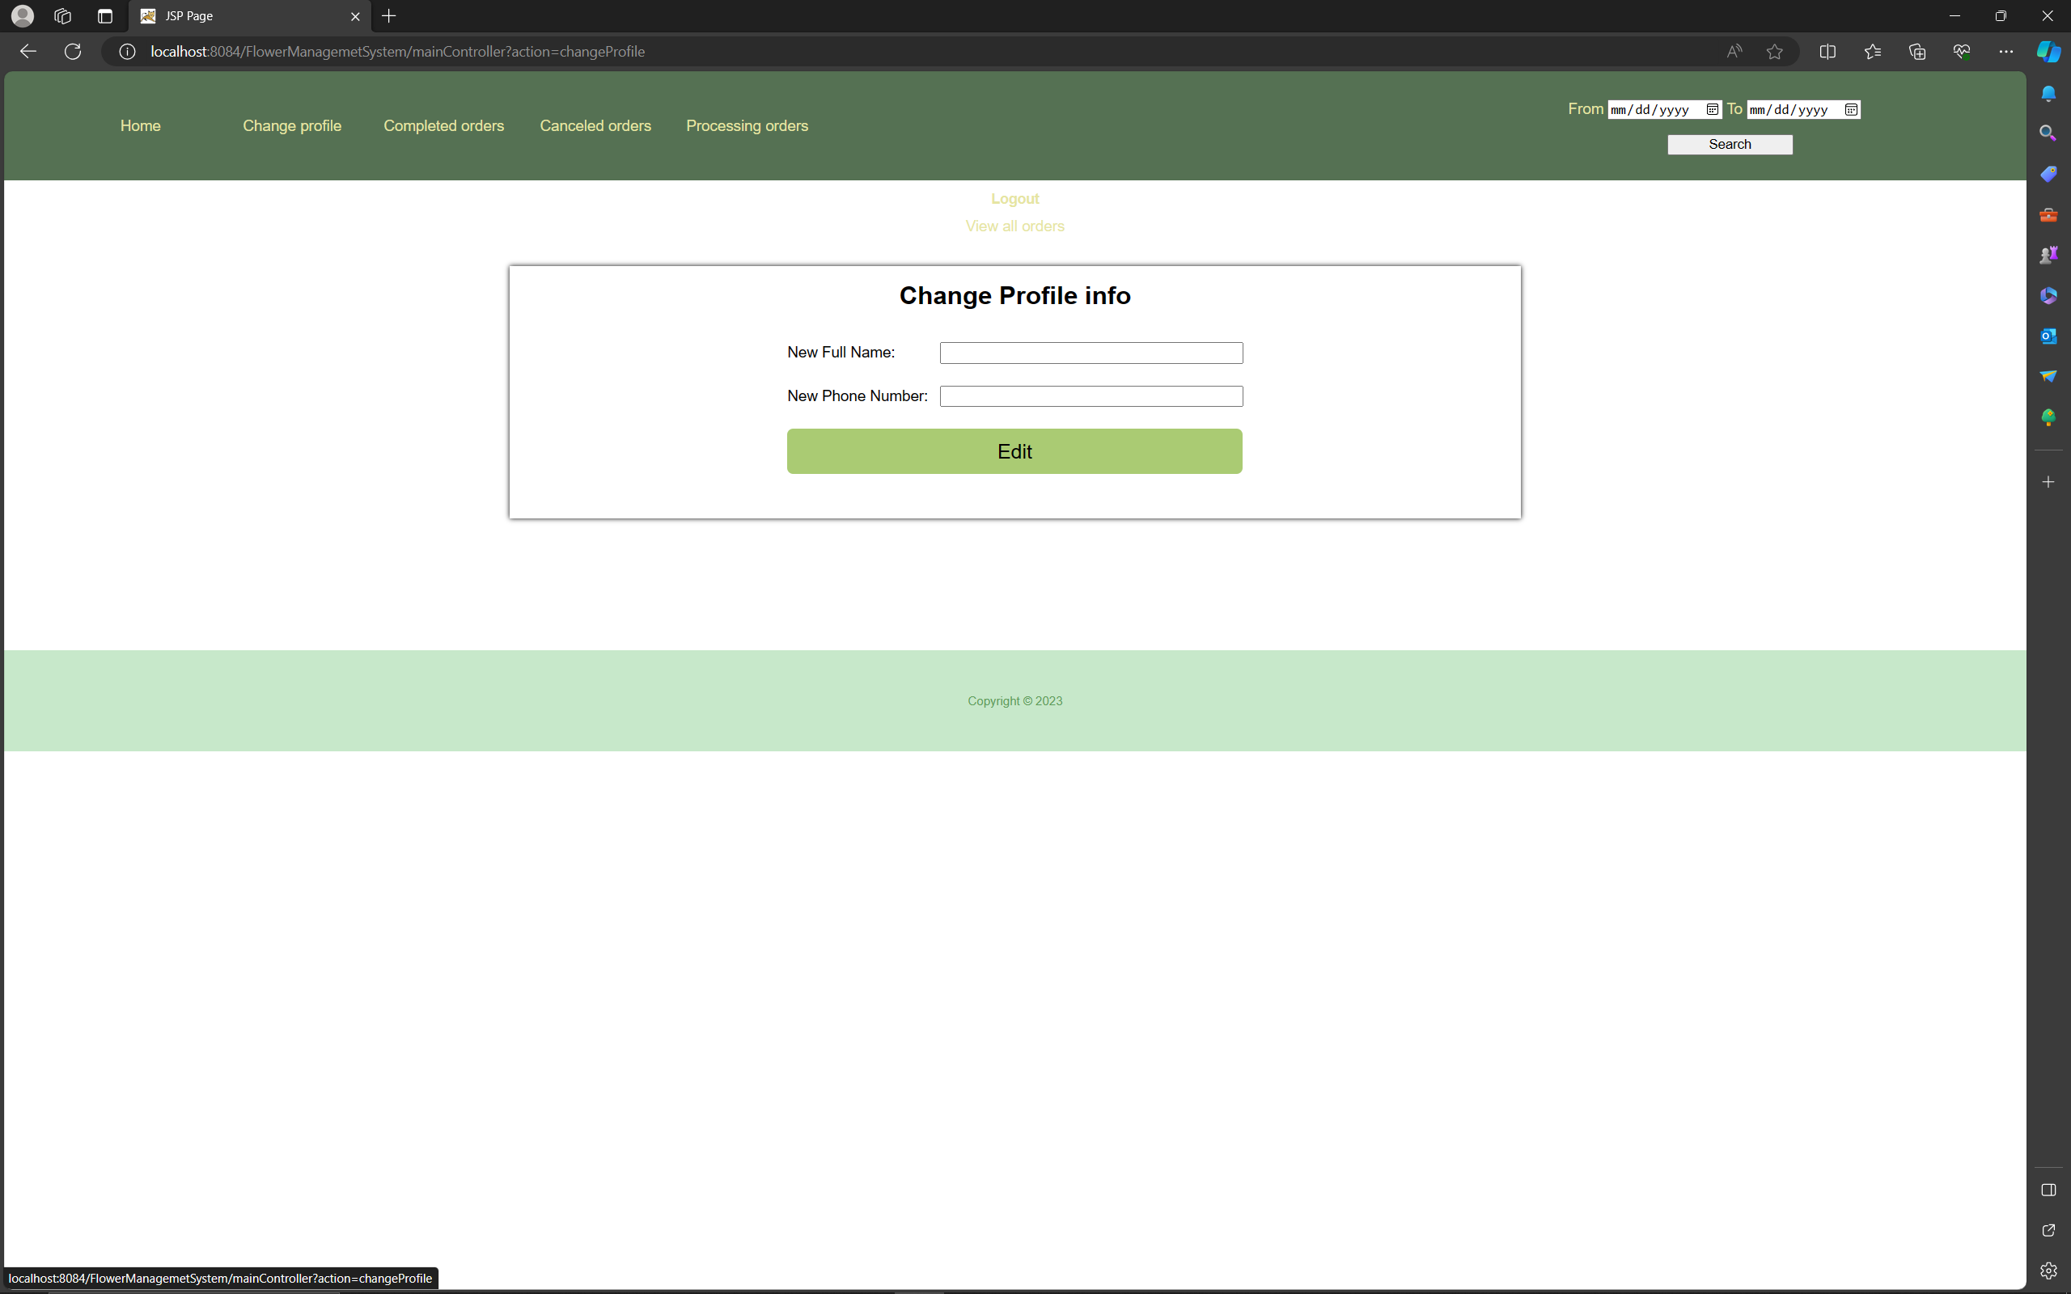

1. **Completed orders**

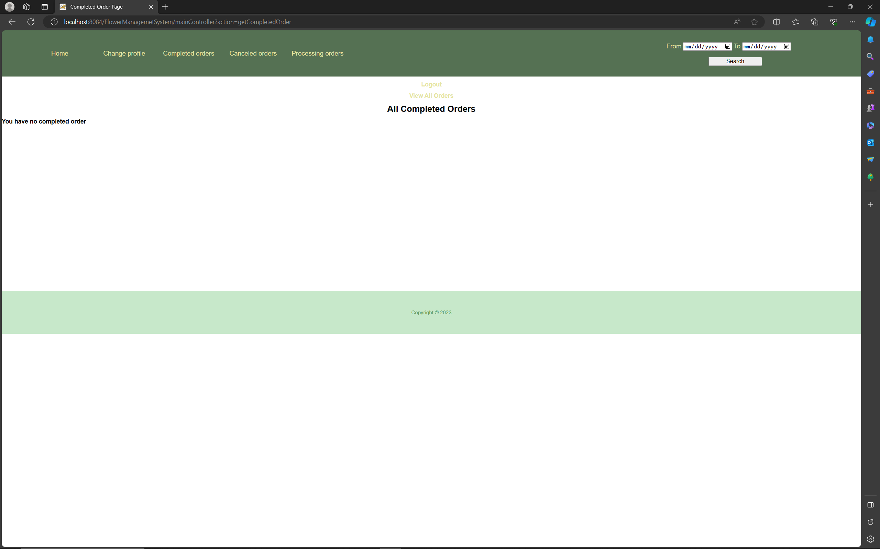

1. **Canceled orders**

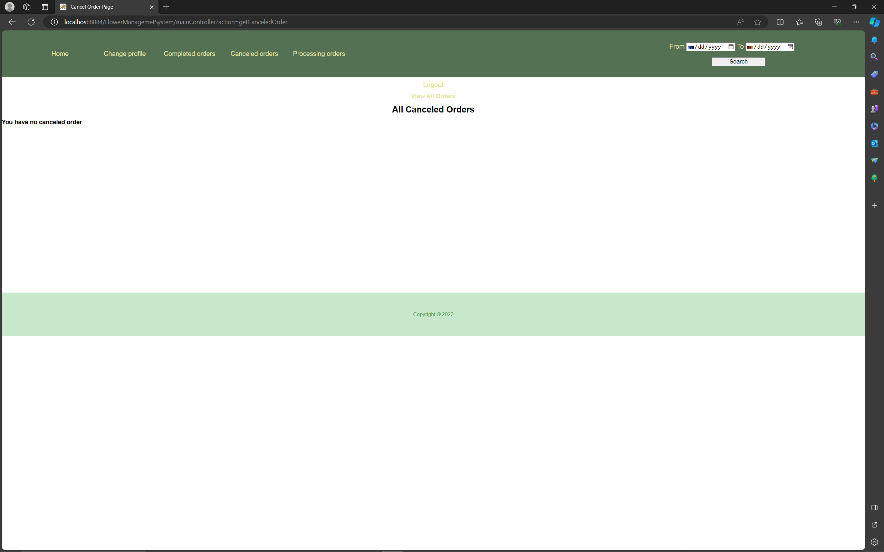

1. **Processing orders**

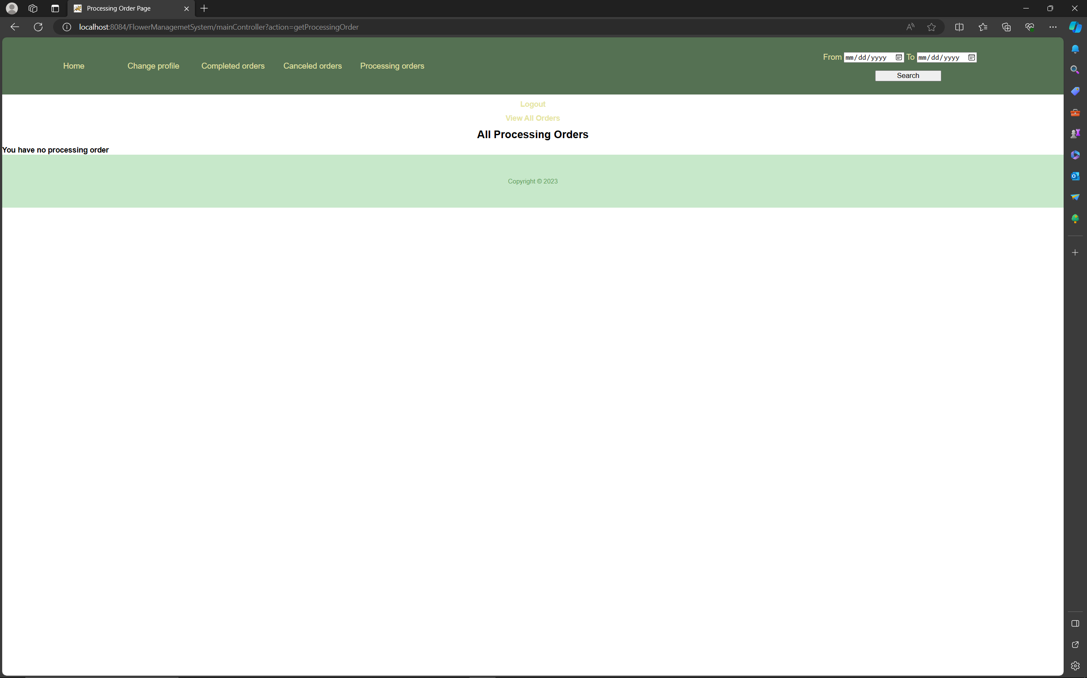

1. **Manage accounts**

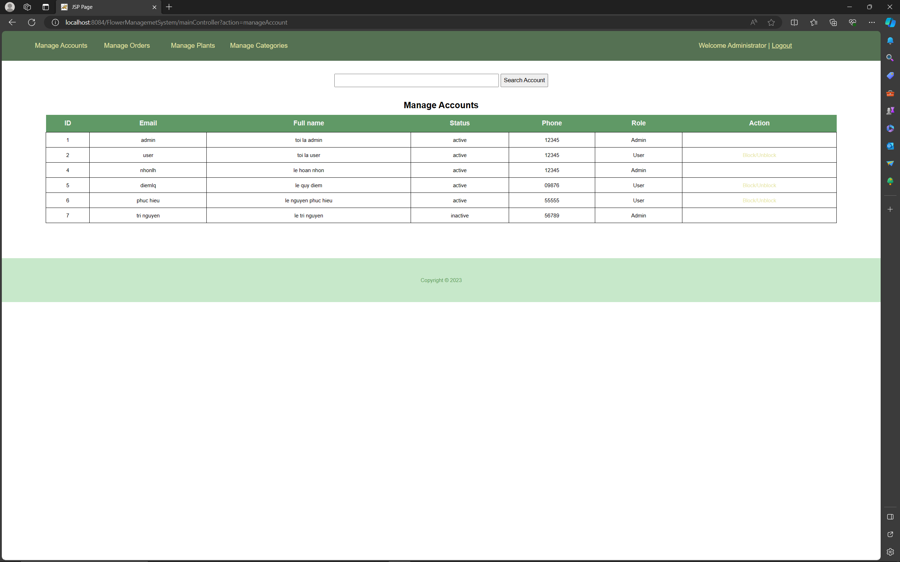

1. **Manage plants**

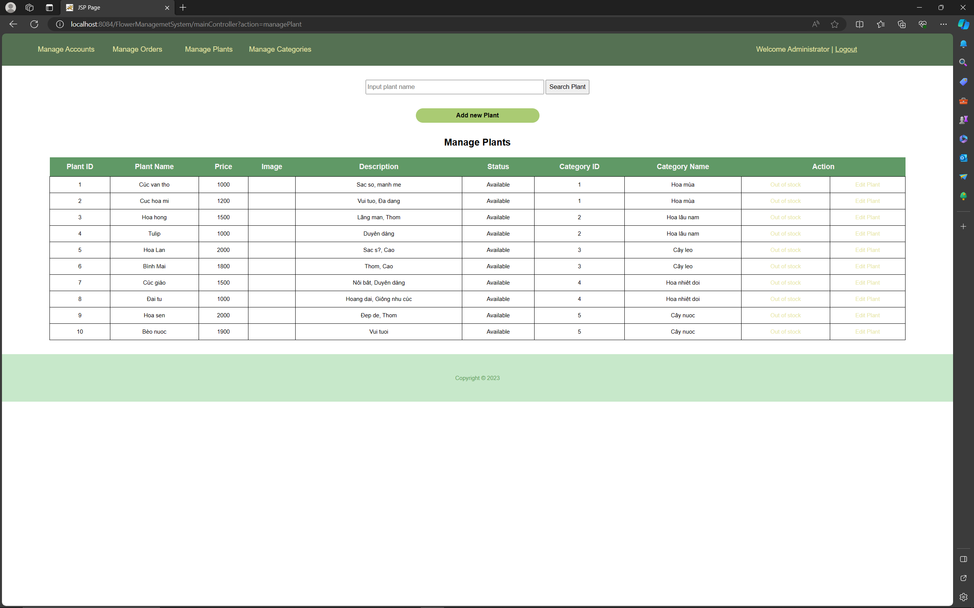

1. **Manage categories**

